**Name: Debjyoti Sarkar Sumonta**

**Student ID: 22341019**

**CSE321 Section 5**

**Lab Assignment 1**

**Task 1 [A]**

Creating files and directory

*touch 22341019_1.txt*

*touch 22341019_2.txt*

*touch 22341019_3.txt*

*touch 22341019_4.txt*

*mkdir Debjyoti1*

*mkdir Debjyoti2*

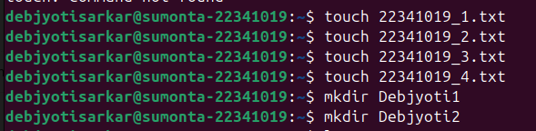

Moving and Copying the files

*sudo mv 22341019_1.txt Debjyoti1*

*sudo mv 22341019_2.txt Debjyoti1*

*sudo mv 22341019_3.txt Debjyoti1*

*sudo cp Debjyoti1/22341019_1.txt Debjyoti2*

*sudo cp Debjyoti1/22341019_2.txt Debjyoti2*

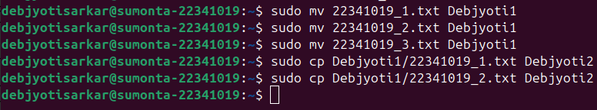

Creating a new directory and copying the contents of another directory and changing the file permission

*mkdir Debjyoti3*

*cp -r Debjyoti1 Debjyoti3/*

*cd Debjyoti3/Debjyoti1*

*chmod 755 22341019_1.txt*

*chmod 755 22341019_2.txt*

*chmod 755 22341019_3.txt*

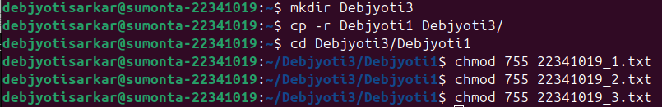

Going back to the original directory

*cd ../..*



All the directories and files in the current working directory

*ls -la*

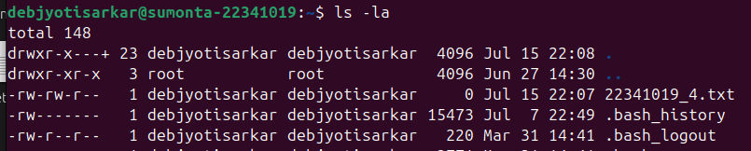

Moving Debjyoti3 to root directory and removing all the other files

*sudo mv Debjyoti3 /*

*rm -rf Debjyoti1 Debjyoti2 22341019_4.txt*



**Task 1 [B]**

Creating a file creating all my current courses and counting the number of course that have CSE

*echo -e "Course ID: CSE484\nCourse Name: Cloud Computing \nSection: 1\nCourse ID: HUM101\nCourse Name: World Civilization \n Section: 03\nCourse ID: CSE321\nCourse Name: OS \nSection:05" >*

*grep -c “CSE” course.txt*

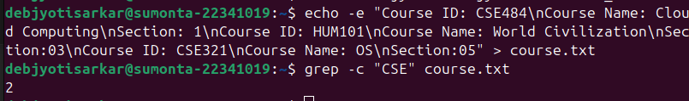

**Task 1 [C]**

Showing all the hidden files in the root directory

*sudo ls -la /root | grep “^\.”*



**Task 1 [D]**

Creating and printing lines 5-17 of a file

*for i in {1..20}; do echo “This is line $i”; done > file.txt*

*sed -n ‘5,17p’ file.txt*

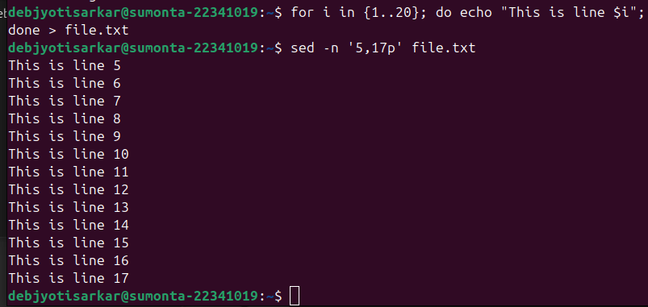

**Task 2 [A]**

#include <stdio.h>

int main() {

int num1;

printf("Type a number: \n");

scanf("%d", &num1);

int num2;

printf("Type a number: \n");

scanf("%d", &num2);

if(num1 > num2){

int result = num1 - num2;

printf("Result: %d", result);

}

else if(num1 < num2){

int result = num1 + num2;

printf("Result: %d", result);

}

else{

int result = num1 * num2;

printf("Result: %d", result);

}

return 0;

}

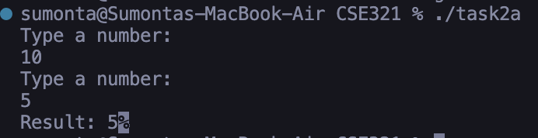

**Task 2 [B]**

#include <stdio.h>

#include <stdlib.h>

int main() {

FILE *input_file = fopen("input.txt", "r");

FILE *output_file = fopen("output.txt", "w");

char c;

int is_space = 0;

while ((c = fgetc(input_file)) != EOF) {

if (c == ' ') {

if (!is_space) {

fputc(c, output_file);

is_space = 1;

}

} else {

fputc(c, output_file);

is_space = 0;

}

}

fclose(input_file);

fclose(output_file);

return 0;

}

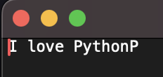

**Task 2 [C]**

#include <stdio.h>

#include <ctype.h>

#include <string.h>

int main() {

char password[100];

int has_lower = 0, has_upper = 0, has_digit = 0, has_special = 0;

printf("Enter password: ");

scanf("%s", password);

for (int i = 0; i < strlen(password); i++) {

if (islower(password[i])) has_lower = 1;

else if (isupper(password[i])) has_upper = 1;

else if (isdigit(password[i])) has_digit = 1;

else if (password[i] == '_' || password[i] == '$' || password[i] == '#' || password[i] == '@') has_special = 1;

}

if (has_lower && has_upper && has_digit && has_special) {

printf("OK\n");

} else {

if (!has_lower) printf("Lowercase character missing\n");

if (!has_upper) printf("Uppercase character missing\n");

if (!has_digit) printf("Digit missing\n");

if (!has_special) printf("Special character missing\n");

}

return 0;

}

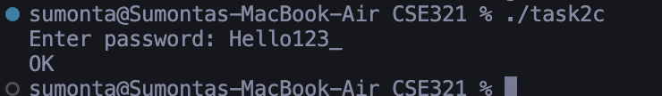

**Task 2 [D]**

#include <stdio.h>

#include <string.h>

int main() {

char email[100];

char old_domain[] = "@kaaj.com";

char new_domain[] = "@sheba.xyz";

printf("Enter email address: ");

scanf("%s", email);

// Check if the email contains the old domain

if (strstr(email, old_domain) != NULL) {

printf("Email address is outdated\n");

} else if (strstr(email, new_domain) != NULL) {

printf("Email address is okay\n");

} else {

printf("Email address is using an unknown domain\n");

}

return 0;

}

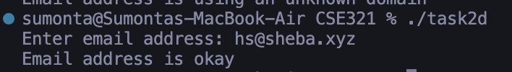

**Task 2 [E]**

#include <stdio.h>

#include <string.h>

#include <ctype.h>

int main() {

char str[100];

char *left, *right;

printf("Enter a string: ");

scanf("%s", str);

left = str;

right = str + strlen(str) - 1;

while (left < right) {

if (*left != *right) {

printf("Not Palindrome\n");

return 0;

}

left++;

right--;

}

printf("Palindrome\n");

return 0;

}

